What Would George Do?
In 1794, just 4 years after the Constitution was ratified by all the states, a direct challenge to the federal government arose. A group of farmers violently challenged a tax on whiskey. Would the Constitution provide ways to stop this rebellion or would it tie the hands of the government like the Articles of Confederation? It was up to the new President to decide.
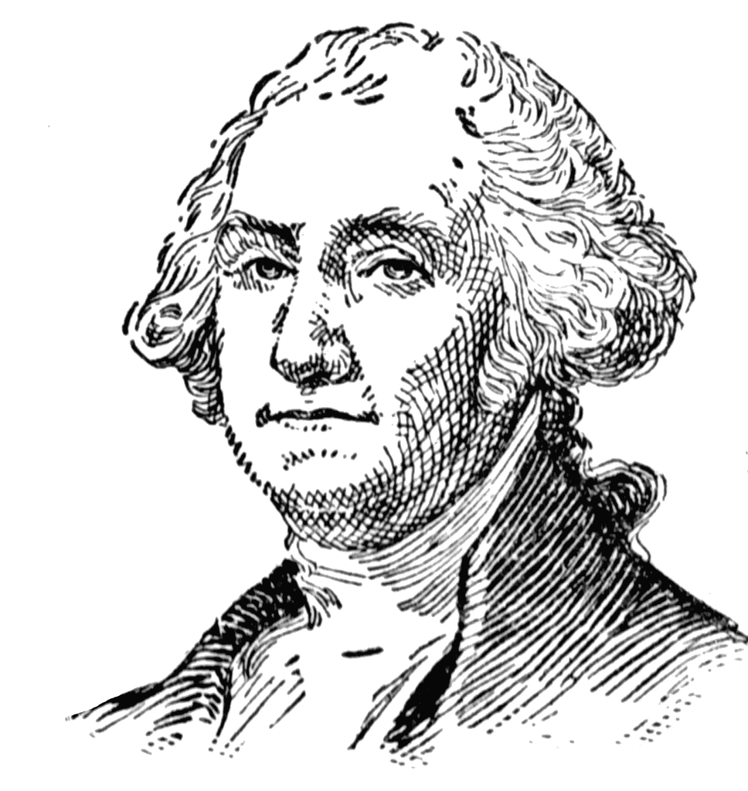
Instructions: In small groups, read the documents on the following pages one by one and answer these questions in complete sentences on your own paper. Answer each set of questions before moving on to the next document. Once all groups are done, discuss your answers as a book club.

Document A: The Whiskey Rebellion
- In a few sentences summarize the problems posed by the Whiskey Rebellion.

- How were these problems similar to those posed by Shay’s Rebellion?

Document B: Selections from the Constitution
- Does the Constitution support the side of the farmers or the government in this case? Explain.

- Based on your reading of these sections of the Constitution should Congress or the President be responsible for dealing with rebellion? Explain.

- If you were George Washington faced with this problem and the limits of the Constitution what would you do to ensure that the problem was solved? Explain in a complete paragraph.

Document C: Washington’s Response
- Summarize Washington’s response to the crisis in a few sentences.

- Do you think Washington’s response was legal based on the Constitution? Explain.

- What is another way Washington could have responded to the crisis? Would this have been a better way? Explain.

Document A:
The Whiskey Rebellion
Angered by a sales tax imposed on whiskey in 1791 by the federal government, farmers in western Pennsylvania petitioned the government to eliminate the tax. When the government refused the farmers engaged in a series of attacks on tax collectors.
While citizens in the east did not find it difficult to accept the concept that new Constitution’s idea individual states were subjects of the national government, people west of the mountains were less accepting of decisions made by the federal government. The tariff [a form of a tax] effectively eliminated any profit by the farmers from the sale of an important money-making crop. More frustrating was the fact that many in the west made whiskey strictly for their own use, not for sale, but were still subject to the tax. This became the lightning rod for a wide variety of frustrations by the settlers of the region against the federal government.
The rebel farmers continued their attacks, rioting in river towns and roughing up tax collectors until the so-called “insurrection” flared into the open in July of 1794 when a federal marshal was attacked in Allegheny County, Pennsylvania. Almost at the same time several hundred men attacked the residence of the regional inspector, burning his home, barn and several outbuildings. Pittsburgh was another scene of disorder by enraged mobs.
This event echoed the earlier “Shay’s Rebellion” where farmers stormed a local courthouse due to anger over economics. That case showed the nation that the Articles of Confederation were too weak to govern the nation. This tax issue challenged the new Constitution, and the new president, in the same way. Since Congress was out of session Washington was called on to respond in some fashion. What would he do?

Document B: Selections from the Constitution

Article 1, Section 8 - Powers of Congress
1. To lay and collect taxes, duties, imposts and excises, to pay the debts and provide for the common defense and general welfare of the United States; but all duties, imposts and excises shall be uniform throughout the United States:
3. To regulate commerce with foreign nations, and among the several states, and with the Indian tribes:
6. To provide for the punishment of counterfeiting the securities and current coin of the United States:
10. To define and punish piracies and felonies committed on the high seas, and offences against the law of nations:
11. To declare war, grant letters of marque and reprisal, and make rules concerning captures on land and water:
12. To raise and support armies, but no appropriation of money to that use shall be for a longer term than two years:
15. To provide for calling forth the militia to execute the laws of the union, suppress insurrections and repel invasions:
16. To provide for organizing, arming and disciplining the militia, and for governing such part of them as may be employed in the service of the United States, reserving to the states respectively, the appointment of the officers, and the authority of training the militia according to the discipline prescribed by Congress:

Article 2, Section 1- The President’s Role
7. Before he enter on the execution of his office, he shall take the following oath or affirmation: "I do solemnly swear (or affirm) that I will faithfully execute the office of the President of the United States, and will to the best of my ability, preserve, protect and defend the Constitution of the United States."

Article 2, Section 2 – Presidential Powers
1. The President shall be Commander-in-Chief of the Army and Navy of the United States, and of the militia of the several States, when called into the actual service of the United States; he may require the opinion, in writing, of the principal officer in each of the executive departments, upon any subject relating to the duties of their respective offices, and he shall have power to grant reprieves and pardons for offenses against the United States, except in cases of impeachment.

Article 2, Section 3 – Presidential Obligations
He shall from time to time give to the Congress information of the state of the Union, and recommend to their consideration such measures as he shall judge necessary and expedient; … he shall take care that the laws be faithfully executed, and shall commission all the officers of the United States.

Document C: President George Washington’s Sixth Annual Message to Congress 1794
…With the deepest regret do I announce to you that during your recess some of the citizens of the United States have been found capable of insurrection [rebellion].
On this call, momentous in the extreme, I considered what might best end the crisis. On the one hand to give in to the traitorous fury of so small a portion of the United States would be to violate the fundamental principle of our Constitution; that the will of the majority will prevail. On the other hand, to put citizen against citizen, to encounter the expense and other embarrassments of a military action, were steps too delicate, too closely tied with other dangers, to be lightly adopted.
I postponed, therefore, the sending of the militia immediately into the field, but I required them to be held in readiness, so that if my peaceful attempts to reclaim the deluded and to convince the malignant of their danger failed, military force might be prepared to act before the season should be too far advanced.
All of those who had committed or aided the riots did not support the peaceful resolution offered to them, and the indications of them desiring peace were not conclusive enough to recommend stopping the march of the militia. Thus the painful alternative could not be discarded. I ordered the militia to march, after once more advising the insurgents to stand down in my proclamation of the 25th of September last.
It has been a spectacle displaying to the highest advantage of republican government to behold the most and the least wealthy of our citizens standing in the same ranks as private soldiers, \preeminently distinguished by being the army of the Constitution - undeterred by a march of 300 miles over rugged mountains, by approach of an inclement season, or by any other discouragement. Nor ought I to omit to acknowledge the efficacious and patriotic cooperation which I have experienced from the chief magistrates of the States to which my requisitions have been addressed.
When in the calm moments of reflection we shall have retraced the origin and progress of the insurrection, let us determine whether it has not been led by combinations of men who, careless of consequences, have spread, from an ignorance or twisting of facts, suspicions, jealousies, and accusations against the whole Government.
Having thus fulfilled the engagement which I took when I entered into office, "to the best of my ability to preserve, protect, and defend the Constitution of the United States", on you, gentlemen, and the people by whom you are deputed, I rely for support.

