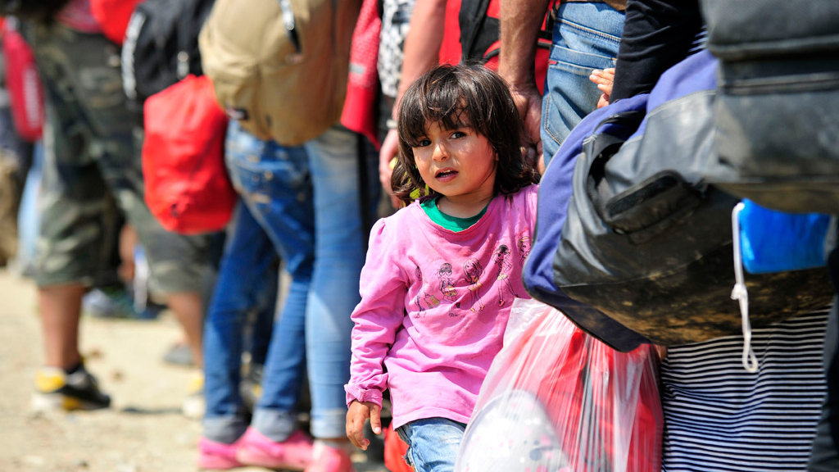
Photo courtesy of United Nations

Student Lesson Packet about the
Syrian Refugee Crisis
and what you can do to help
Name: _____________________________________
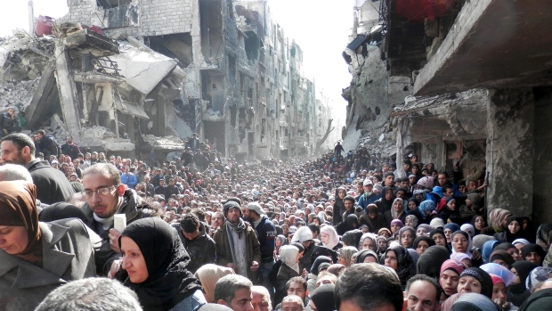
Photograph by Associated Press.
Some Key Vocabulary and Players that you may hear during this class:
- Refugee:
a person who has been forced to leave their country in order to escape war, persecution, or natural disaster—all in order to save their life

- Migration:
when a group of people move from one section of the world to another, for reasons of safety, freedom, or new opportunities

- Migrant:
A person who moves to another country for new economic opportunities
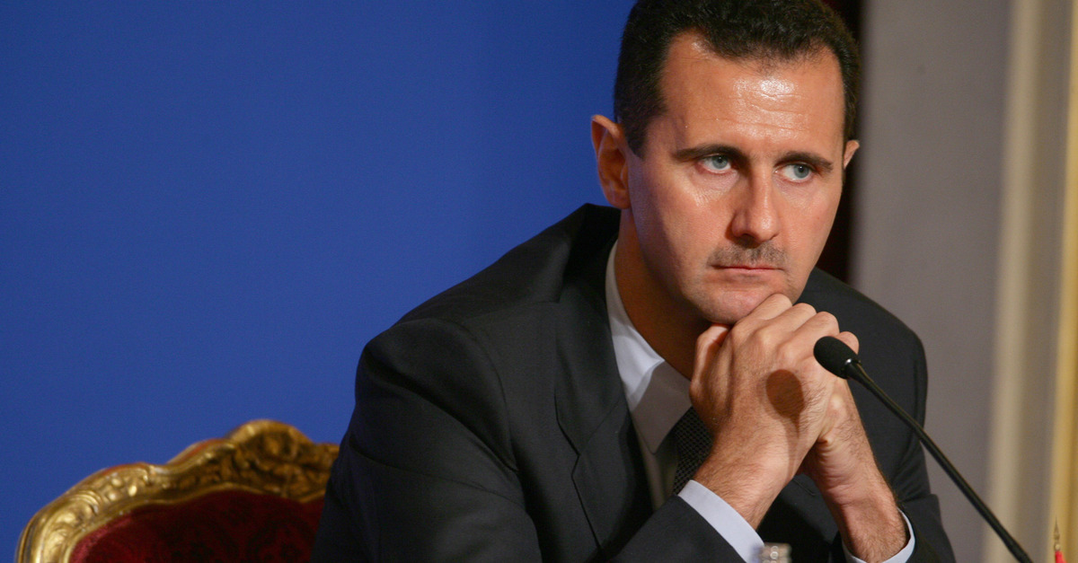Bashar al-Assad
- Bashar al-Assad:
dictator of Syria

- ISIS:
The Islamic State in Iraq and Syria, also known as the IS (Islamic State) or ISIL (Islamic State of Iraq and the Levant)

- European Union:
An association of 28 European nations

- Asylum:
When a country legally accepts a refugee to live in their country
Student Lesson Packet on the Syrian Refugee Crisis Page One
The text of the video you just saw:
For many Americans, the stories of how their relatives came to the United States is a source of inspiration, hope, and amazement. As a nation of exiles, we take great pride in how our ancestors survived slavery, persecution, famine, and war, arriving here penniless, as “huddled masses yearning to breathe free.”
Today however, the story of millions of Syrians who are escaping their country’s troubles remind us that every human being is important, that each has dignity, and is worthy of the same happiness that attracted our own families to America.
Escaping the barrel bombs and poison gas of the dictator Bashar al-Assad that have killed over 250 thousand of their countrymen—as well as the barbaric cruelty of the terrorist group ISIS—millions of average, middle class Syrians now face the decision of a lifetime.
Facing almost certain death if they remain in their country, should they flee to a neighboring refugee camp in which they might be confined for years?; or, sell their life’s possessions to pay for a smuggler to take them and their famlily to Europe…
The decision to use smugglers is frought with danger, trauma, and quite frequently, death. Often paid to take more people then they should, these smuggling rings are incredibly dangerous, crossing the Mediterranean on crowded dinghies and rafts, with over 3,000 people dead or missing this year alone.
One of those victims was a three-year old Syrian boy named Ay-lahn Kurdee, whose body washed up on the shore of Turkey after the boat he was on capsized, also killing his mother, and brother.
To go over land to Europe is equally as challenging, as shown by images of an abandoned smuggler’s truck in Austria that contained over 70 dead Syrians who were hoping to get to Germany.
Given that the situation continues to deteriorate, the United Nations has estimated that over a million refugees are en route towards Europe, with possibly five million more headed that way by the end of the year.
This means that over 4,000 people are arriving every day, prompting many countries to close off their borders, leaving thousands stranded without hope or a future.
To make matters worse, according to Nick Kristof of the New York Times, only 41% of the United Nations food requests for these refugees have been funded by governments around the world, with over half of Syrian chidren unable to go to school.
In some ways, the current situtation reminds us of the 1930’s, when thousands of European Jews were attempting to leave Nazi Germany, only to see that the world looked away, leading to the continued suffering and death of millions, known as the Holocaust.
As people who care about the world, what should our response to Syria be today?
How many refugees can other countries absorb?
How will the fighting be stopped so that people can return home?
Syria as the world once knew has ceased to be; posing problems that effect all of us. The longer the conflict continues, the more the human sufferering will intensify, creating a breeding ground for terrorism and extremism. It is the crisis of our generation.
Student Lesson Packet on the Syrian Refugee Crisis Page Two

Section One: Introductory Video—after watching, please answer the questions that follow…
(Link to video is on the Situation in Syria webpage)
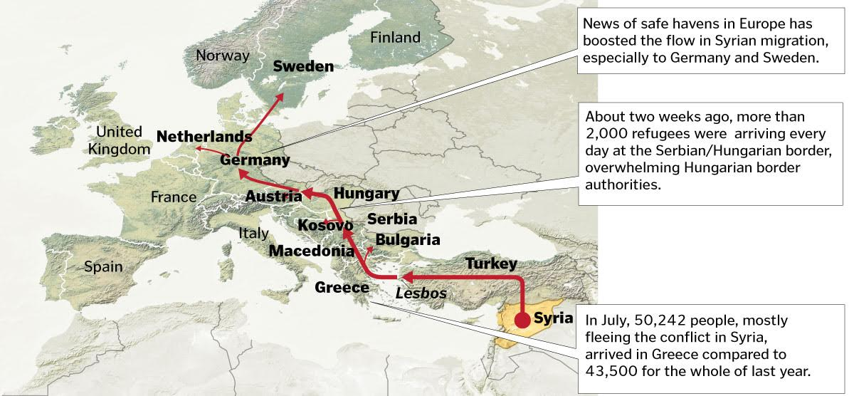
Mediterranean Sea
Africa

- Circle Syria on the map.

- Find and circle Turkey on the map – circle the part of the Mediterranean Sea that thousands of Syrians are crossing over to Greece.

- Reread the text of the video that’s located on the previous page.
What are three reasons why the people of Syria are leaving their country?

- ____________________________________________________________________
- ____________________________________________________________________
- ____________________________________________________________________

Student Packet on the Syrian Refugee Crisis Page Three

Section Two:
Using the BBC’s website: Syrian Journey--Choose your own escape route
http://www.bbc.com/news/world-middle-east-32057601 (Link is on the Refugee Page)
While watching the escape routes and watching the survivor videos, list five hardships or problems Syrians face when trying to escape their country…
- ________________________________________________________________
- ________________________________________________________________
- ________________________________________________________________
- ________________________________________________________________
- ________________________________________________________________

