Salt Dough Map Instructions – Level 1

- Draw your continent with pencil -it may need to be changed.
- Select 3-4 popsicle sticks to get assigned climates.
- Split your continent into 3-4 countries --draw borders on your map.
  - Trace your continent onto the cardboard box.
  - Cut out your individual climate from the continent.
- Choose where to place your landforms and waterways onto your continent.
  - Use the “Salt Dough Landform Choices” chart on weebly to pick landforms appropriate to your 4 climates.
  - Check your work using the answer key.
- Have Mrs. Wente approve your climate.
- After approval, help your teammates with their climate. **Two teammates must be approved before you can move onto Level 2.
- Write your names on the outside of the cardboard box as well as your team color.
- Move onto Level 2 to make the salt dough.
  - Follow the salt dough instructions on weebly.

Salt Dough Map Instructions – Level 2
Ingredients:
- 4 cups flour
- 1 cup salt
- 1 cup hot water (from the sink)
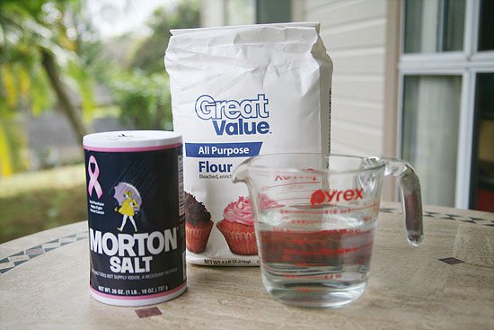
Directions:
- Pour the salt & flour together into the mixing bowl. Stir.
- Add hot water to the bowl. Stir -Caution: Contents are HOT.
- Mix ingredients together until the dough becomes stiff. Remove the spoon and continue to mix together by hand (knead the dough) until the dough becomes elastic. –During this step have another person wash the dishes.
- If your mixture turns out too sticky, GRADUALLY add more flour.
- If it turns out too crumbly, GUADUALLY add more water. –Do not add more than an additional ½ cup.
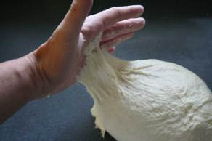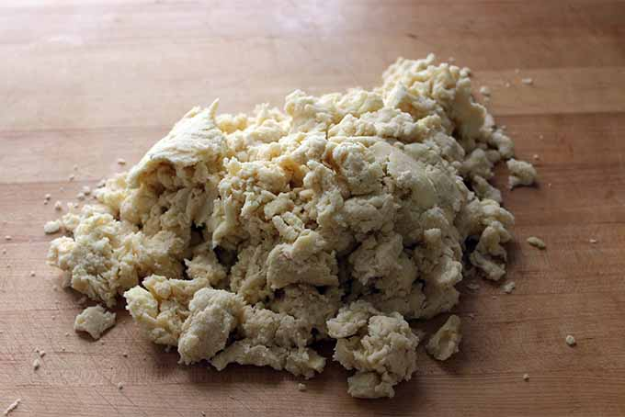
Sticky dough is too wet. Sticks to your hands. Crumbly dough is too dry. Won’t stick together in a ball.
After salt dough is ready place it within the outline of your continent (on the cardboard). Spread out thinner is better.
Salt Dough Map Instructions – Level 3
- Shape your landforms and waterways on the continent.
  - Reference the “Salt Dough Landform Choices” when designing your landforms and waterways.
  - Remember the landforms and waterways that you choose to create depends upon the type of climate that they are in. Example: It doesn’t make sense for a butte to be in a tropical climate.
- Once you’ve finished shaping your landforms and waterways place your box on the counter to let the dough dry.

