Republic Grows and Strengthens Text Questions
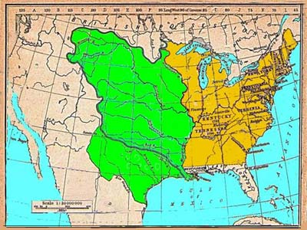

- What is the area between the Rockies and the Mississippi River called?
- Who was the leader of France during Jefferson’s presidency?
- Why did France want to get rid of their American lands? (3 reasons)

- Why did Americans want control of New Orleans and the Mississippi River?
- When did Jefferson double the size of the US, and how much did he pay per acre?
- What purpose did Sacagawea serve on the Lewis and Clark expedition?
- Which direction did Pike travel?
- What was Jefferson’s reaction to the French and British messing with our ships and sailors?
- Who was the Native leader who tried to fight back against Americans?
- What do you call someone who is trying to get America to go to war?
- What did Britain do in the war between 1812 and 1814?
- What did Oliver Perry’s flag say?
- Why did the British strategy change in 1814?
- How many naval ships and troops did we have in 1812?
- What happened to the US capital city in 1814?
- What did Dolly Madison “save”?
- What inspired Francis Scott Key to write the lyrics to the Star-Spangled Banner?
- Where is the original star-spangled banner today?
- What was the margin of victory at the Battle of New Orleans?
- What was unusual about the timing of the Battle of New Orleans?
- What were the four unintended consequences of the War of 1812?

