Name ______________
Latitude/Longitude – Can I Do This?
Use the page numbers for each question in order to answer each question.
- PAGE A30-31: What city lies closest to 30` N, 120` W?

- PAGE A30-31: If someone crashed a plane at 15` S, 150` W, near what island country would they have crashed?

- PAGE A12-13: If your mom just got a new job and you’re moving to a beach house at 20’N, 75`W, what island country are you moving to?

- PAGE 5: A meteor is rocketing to Earth; CNN announces it will land near 36`N, 140` E, which city will it land nearest?

- PAGE 7: Which city is closer to the equator – Hamburg or Munich?

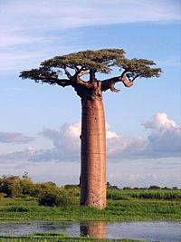
- PAGE A4-A5: The pink island of Madagascar is southeast of Africa and home to the baobab trees and the leaping lemur. On this map, what line of latitude crosses Madagascar (hint: the answer is NOT Tropic of Capricorn)?

- PAGE A4-A5: What island country sits at 40` N, 140` E?

- PAGE A4-A5: What continent sits at 30` S, 140` E?

- PAGE A4-A5: What country am I standing in if I am at 40`N, 100` W?

  - Use the map below to answer the following questions:
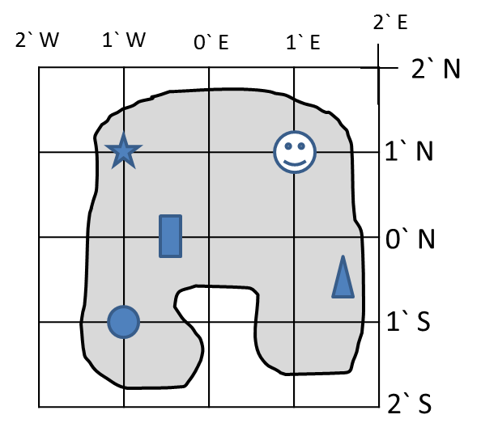
10. Which symbol is sitting at 1` N, 1`W?
a. circle
b. star
c. smiley face
d. none of the above

11. Which symbol is sitting closest to 1’ S, 1’ E?
a. smiley face
b. rectangle
c. triangle

12. Which of the coordinates below is the BEST way to describe where the rectangle is sitting?
a. 0`E, 0` N
b. ½’ W, 0` N
c. 0’ N, ½`, W
d. 0` S, 1` W

